Python Programming Lab Task Sets

Set 4
- Q1. Create a function to reverse a list in Python. Use an AI tool to suggest alternative implementations. Test and compare the performance of each version.

PROMPT: WRITE A PYTHON CODE FOR A FUNCTION TO REVERSE A LIST BY SUGGESTING ALTERNATIVE IMPLEMENTATIONS TO TEST AND COMPARE THE PERFORMANCE PF EACH VERSION .BY ASKING USER INPUTS
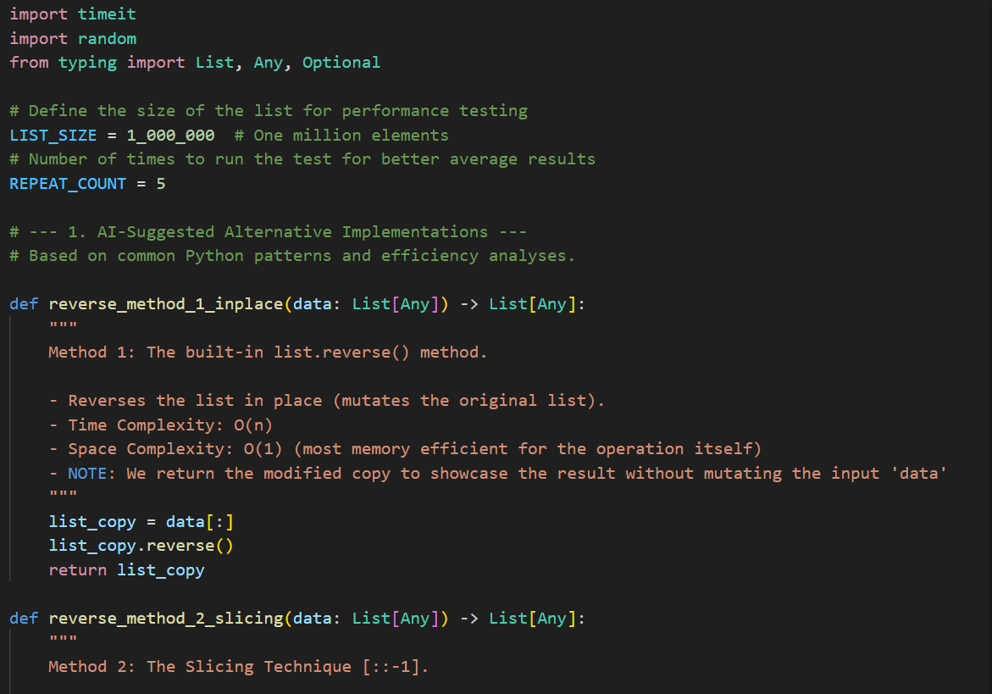
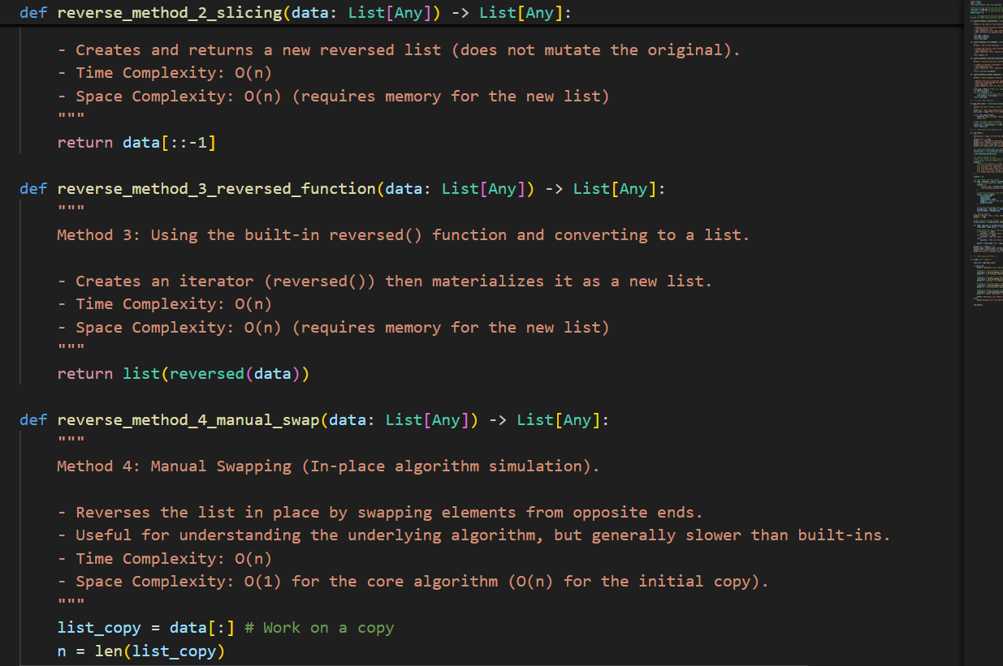
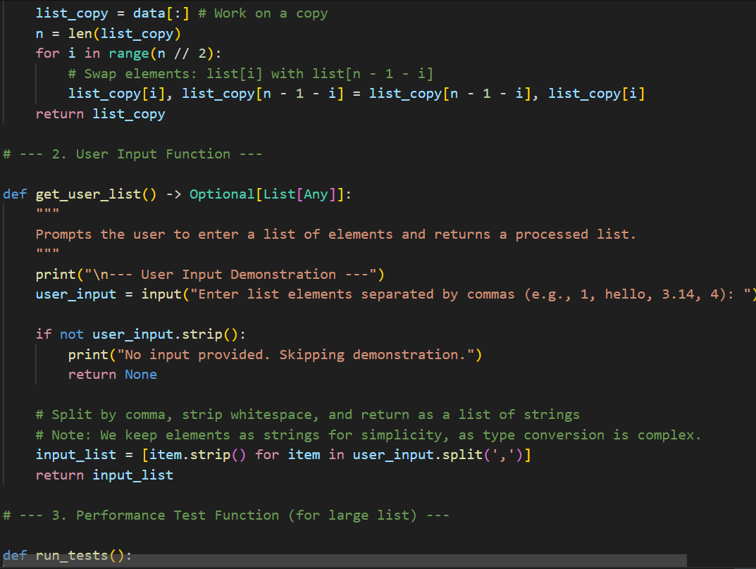

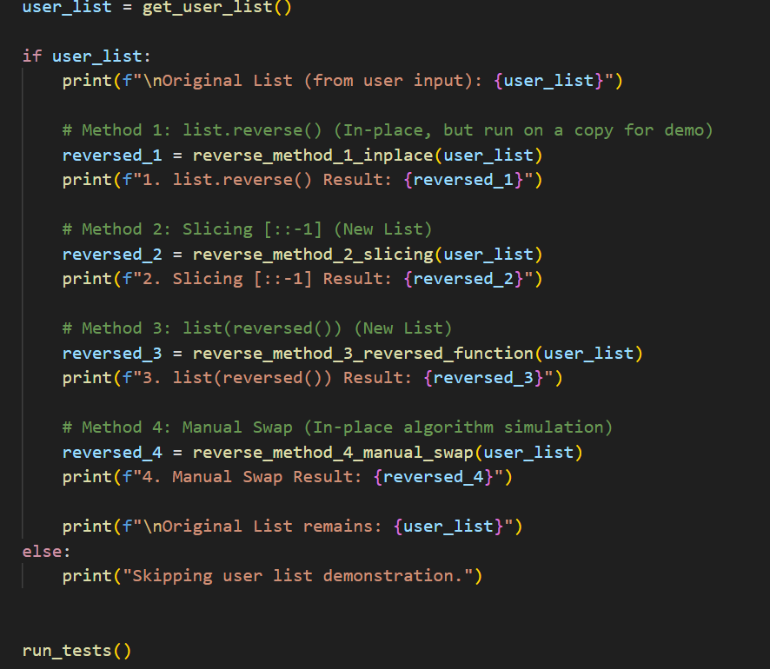
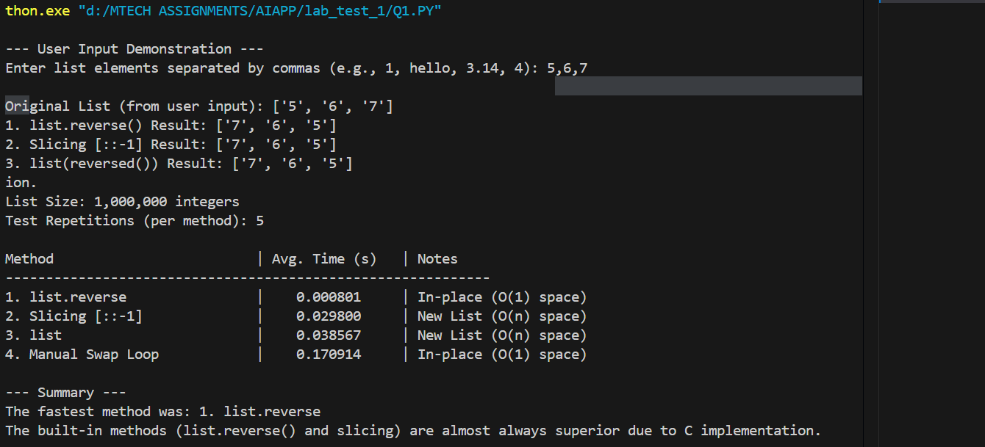
- Q2. Design a few-shot prompt to guide an AI tool in writing code for a basic linked list with methods for insert and delete. Analyze the resulting code for correctness and completeNESS

PROMPT: WRITE A PYTHON CODE FOR BASIC LINKED LIST WITH METHOD FOR INSERT AND DELETE AND ANALYZE THE CODE FOR CORRECTNESS AND COMPLTENESS .BY ASKING USER INPUTS
